**CSA1086 - Software Engineering**

GitHub branching and merge

1. Create a New Branch feature-login



1. Create a login.py File with a Simple Login Function

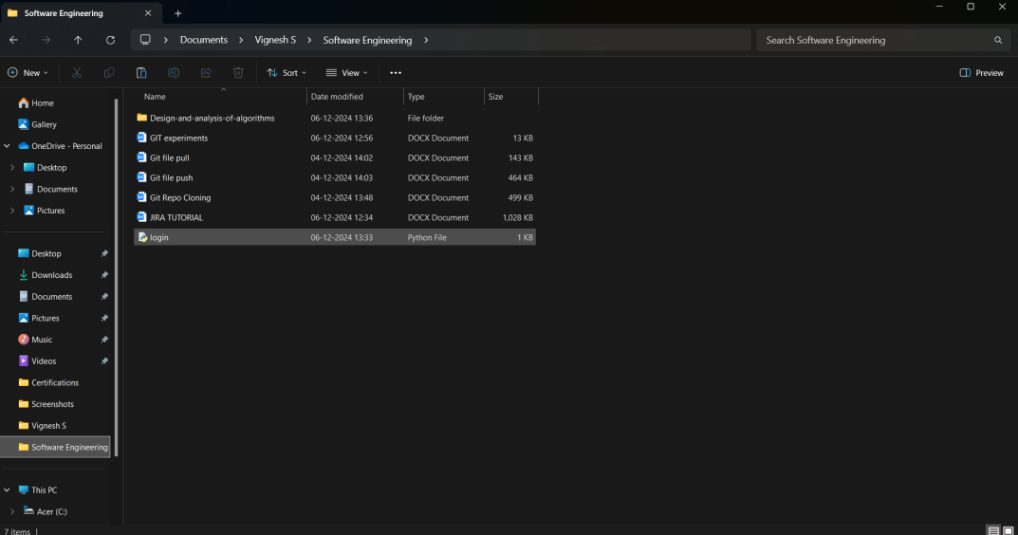

1. Commit the Changes

Screenshot 2024-12-06 135240



1. Push the Changes to GitHub

Screenshot 2024-12-06 135557

1. Create a Pull Request (PR) on GitHub

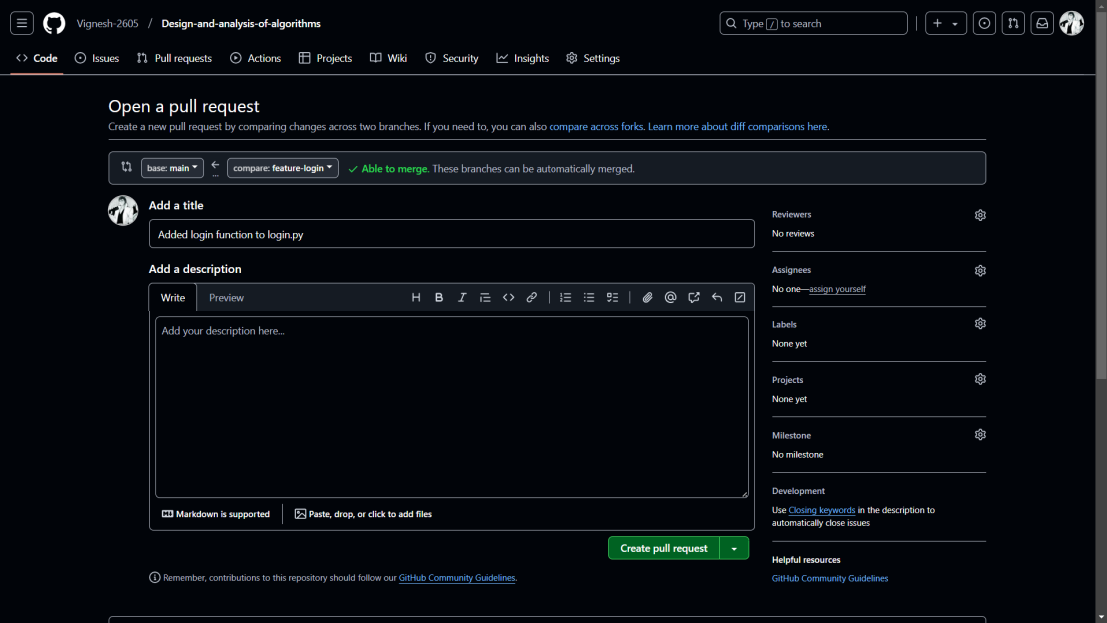

1. Merge the Pull Request

